

**SESEC V Translation**

**Translation of Understand China’s National Guidelines for the Development of the Intelligent Manufacturing Standards System (2024 Edition)**

**May | 2025**



**Seconded European Standardization Expert in China**

**(SESEC)**

**INTRODUCTION:**

In 2025, the Ministry of Industry and Information Technology (MIIT) and the Standardization Administration of China (SAC) jointly issued the fourth revision of the National Guidelines for the Development of the Intelligent Manufacturing Standards System (2024 Edition).

Building upon the 2021 edition, the new guidelines optimize the standards framework and structure, with a stronger focus on the integration of emerging technologies—such as artificial intelligence—into manufacturing.

It expands standard development in three key areas, including**: Intelligent equipment**, **industrial software**, and **new intelligent manufacturing models**. It also revises standards in three areas, including **basic and foundational standards**, **intelligent empowering technologies**, and **electronic information applications**. The document further clarifies measures for organizational implementation.

To help the relevant local government bodies, standard associations and other compliance stakeholders understand and adapt to the new development guidelines, MIIT has released an infographic help them grasp key updates and strategic direction in the coming years.

SESEC has translated the original infographic for European stakeholders to ensure that those actively engaged in business with China are also kept informed.

Here is the link to the original infographic from MIIT:

<https://wap.miit.gov.cn/jgsj/kjs/gzdt/art/2025/art_d650391ad8794c96b09ac0deb582f27a.html>

**DISCLAIMER:**

This English version is an unofficial translation of the original Chinese document, produced by SESEC for reference purposes only. In the event of any discrepancies between the English and Chinese versions, the Chinese version shall prevail. SESEC accepts no responsibility or liability for any errors, inaccuracies, or misunderstandings arising from this translation.

**Understand China’s National Guidelines for the Development of the Intelligent Manufacturing Standards System (2024 Edition)**

**Introduction**

Intelligent manufacturing is a strategic and leading task in accelerating the advancement of new industrialization and developing new productive forces in the new era and on the new journey. At present, China’s intelligent manufacturing has entered a new stage, transitioning from “concept dissemination and pilot demonstration” to “deepened application and comprehensive promotion.” To effectively leverage the supporting and guiding role of standards in driving the high-quality development of intelligent manufacturing, the Ministry of Industry and Information Technology and the Standardization Administration of China have jointly issued the **National Guidelines for the Development of the Intelligent Manufacturing Standards System (2024 Edition)**.

1. **General Requirement:**

Guided by Xi Jinping Thought on Socialism with Chinese Characteristics for a New Era, and fully implementing the spirit of the 20th National Congress of the Communist Party of China and the Third Plenary Session of the 20th Central Committee, this initiative earnestly follows the decisions and arrangements made at the Central Economic Work Conference and the National Conference on Advancing New Industrialization. It also thoroughly implements the requirements set out in the National Standardization Development Outline and the 14th Five-Year Plan for the Development of Intelligent Manufacturing. With firm commitment to the strategies of building a strong manufacturing nation and cyber power, efforts will continue to improve the top-level design of intelligent manufacturing standardization. High-quality standards for intelligent manufacturing will be leveraged to support the development of a modern industrial system and to promote the high-end, intelligent, and green transformation and upgrading of the manufacturing industry.

1. **Three Fundamental Principles**

* **Holistic Planning with Forward-Looking Guidance**
* **Demand-Driven with Application-Oriented Expansion**
* **Based on National Conditions with Openness and Cooperation**

1. **Construction Objective:**

By 2026, **more than 100 national and sectoral standards** will be formulated or revised, forming an intelligent manufacturing standards system that aligns with the needs of emerging industrialization.

1. Standards for intelligent equipment, industrial software, intelligent factories, and intelligent supply chains are increasingly being improved.
2. Standards for empowering technologies, new intelligent manufacturing models, and industrial networks are being developed at an accelerated pace.
3. Successful practices and innovative outcomes are being distilled and solidified to support the establishment of enterprise-level intelligent manufacturing standards systems.
4. **Development Approach:**

Building on the existing standard system structure that encompasses:

1. **Basic and foundational standards**,
2. **Key technologies**, and
3. **Industrial applications**,

The approach remains committed to **directionality**, **systematic planning**, and **innovation**. New standards have been laid out in industrial software, standards for new integrated production-and-sales operation models have been added. Application standards for industries such as chemicals and light industry have been expanded. In addition, standards for intelligent-empowering technologies have been further optimized. Below picture illustrates the architecture of the 2024 Intelligent Manufacturing Standards System described in the national guideline:

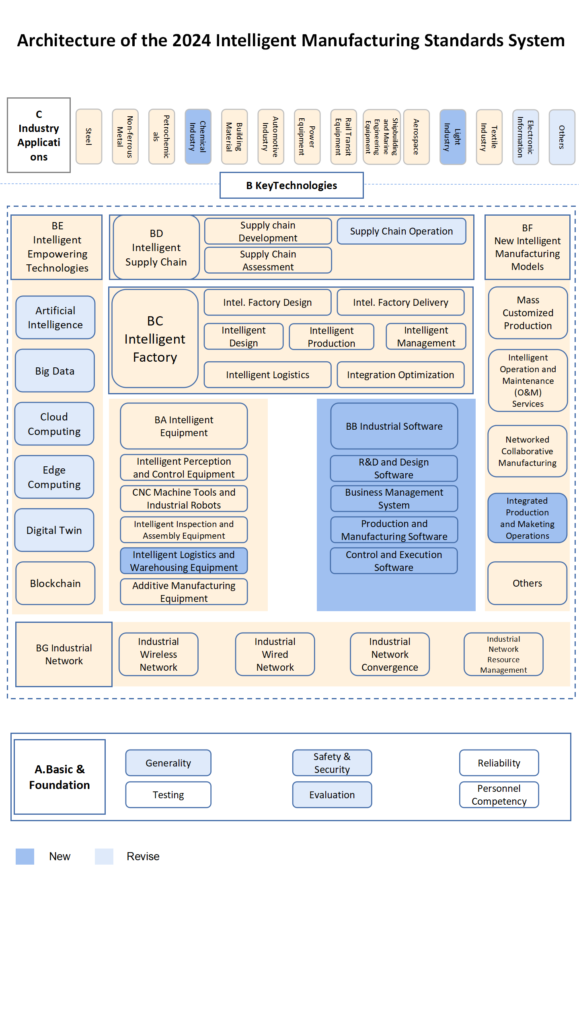

1. **Development Focus**
2. **Basic and Foundational Standards**

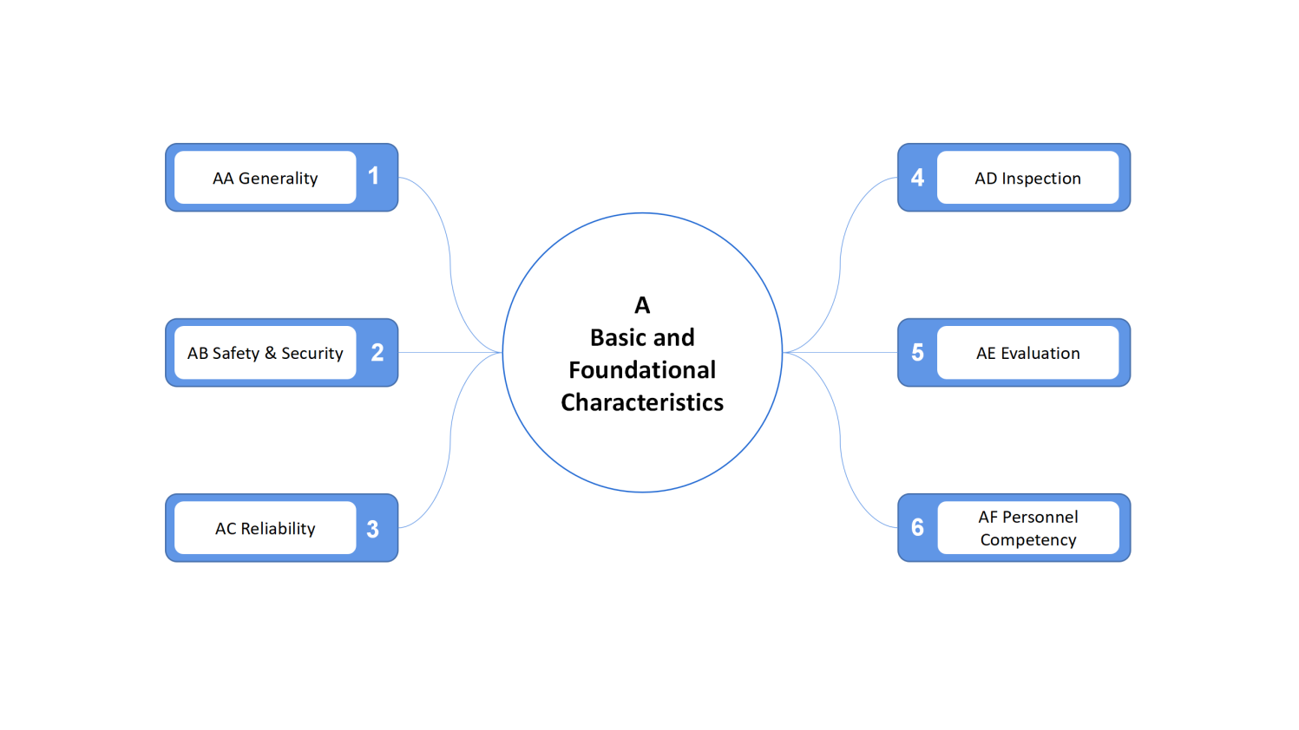

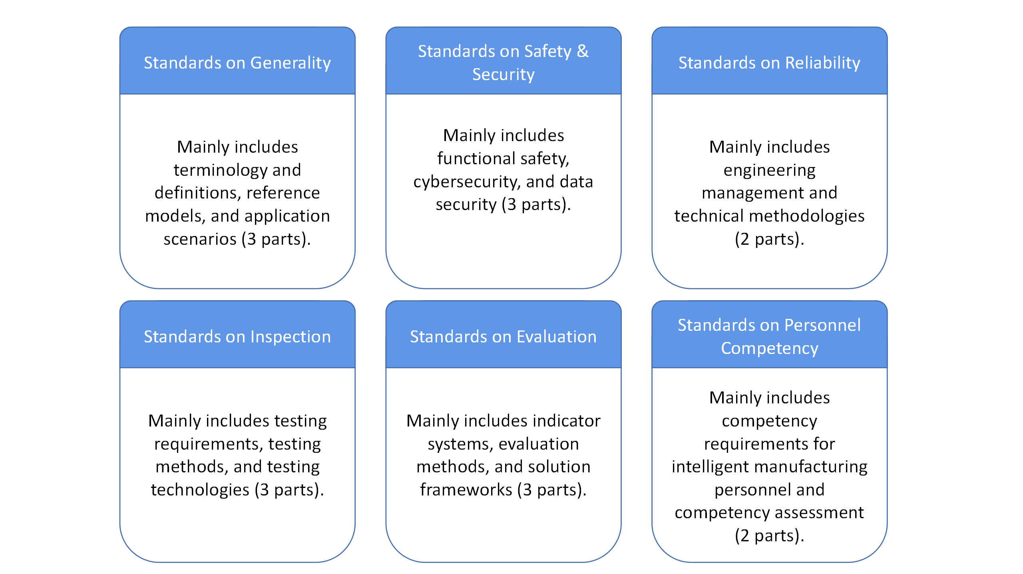

1. **Key Technologies**

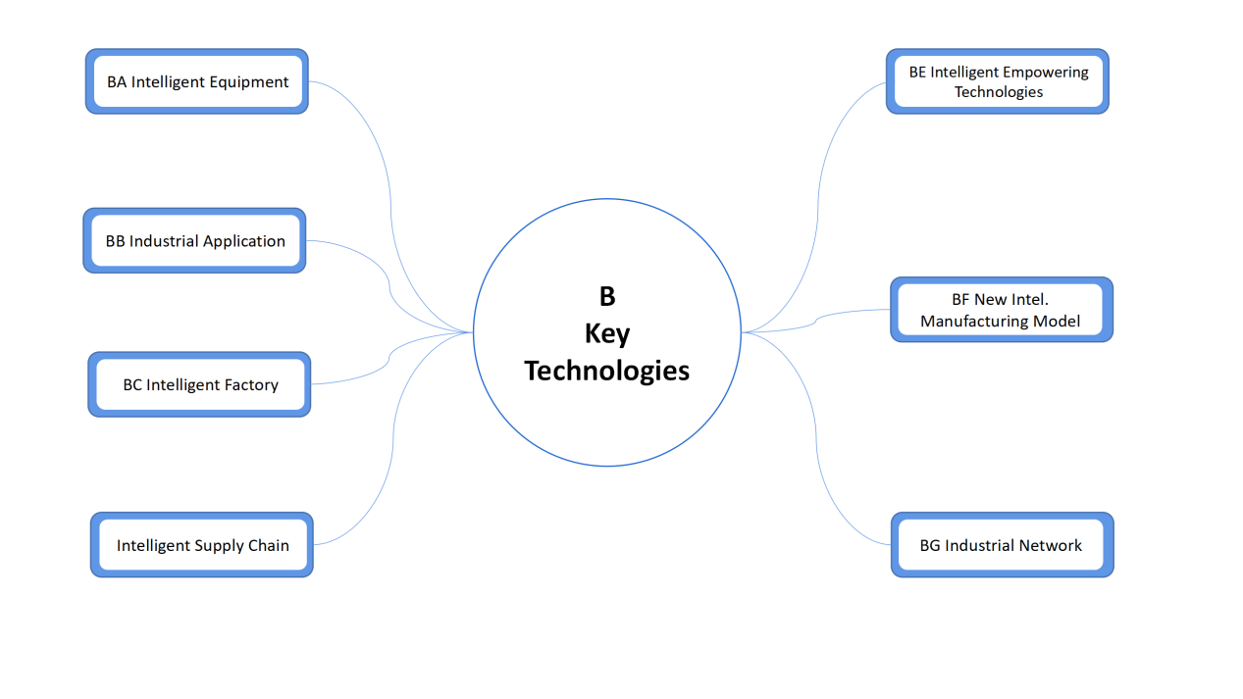

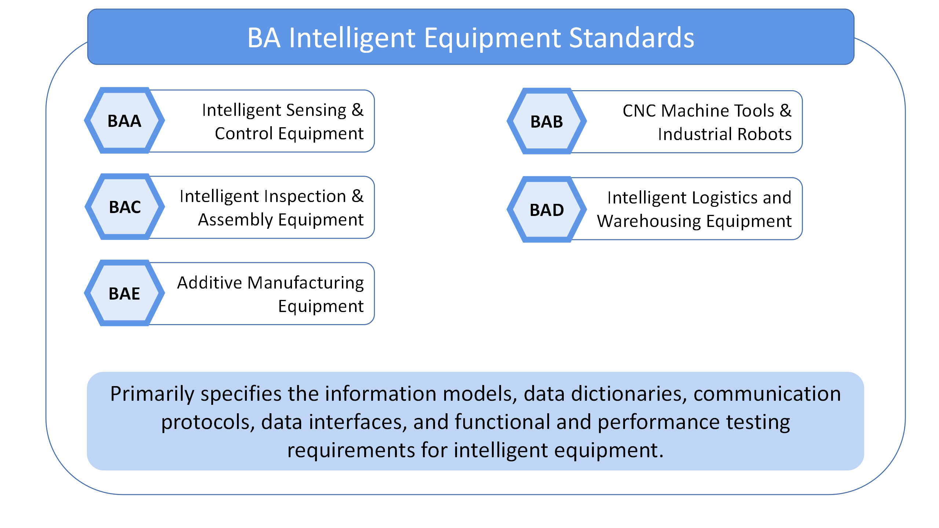

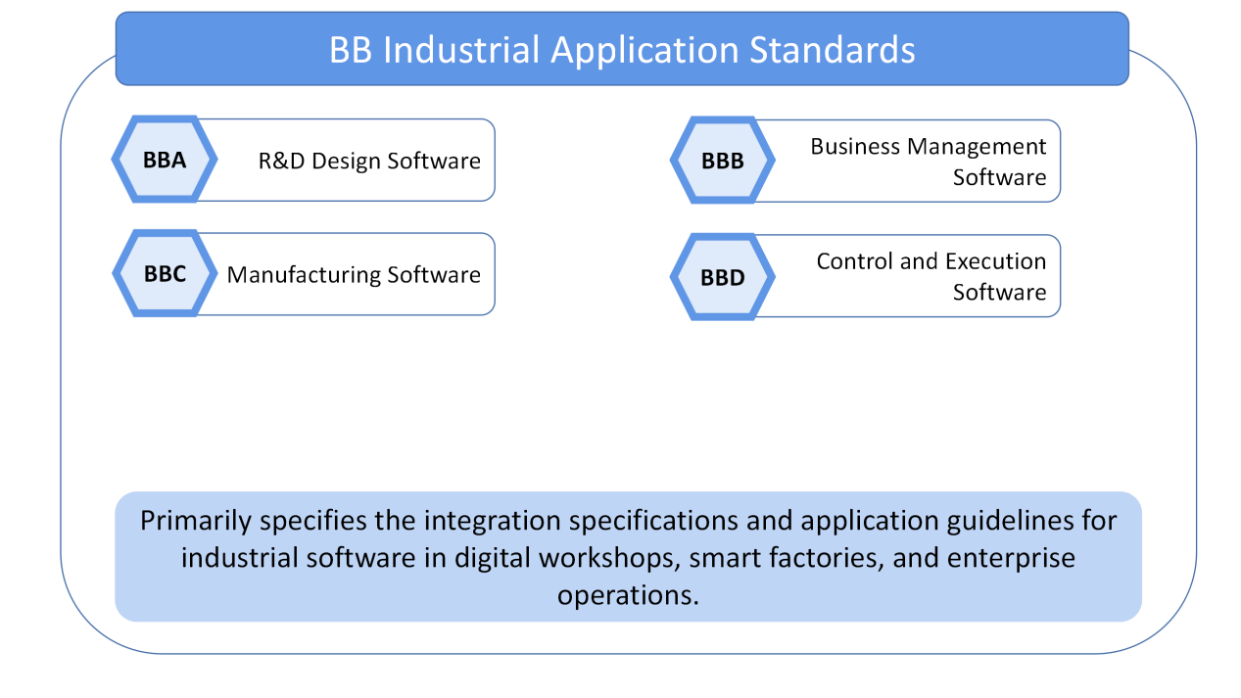

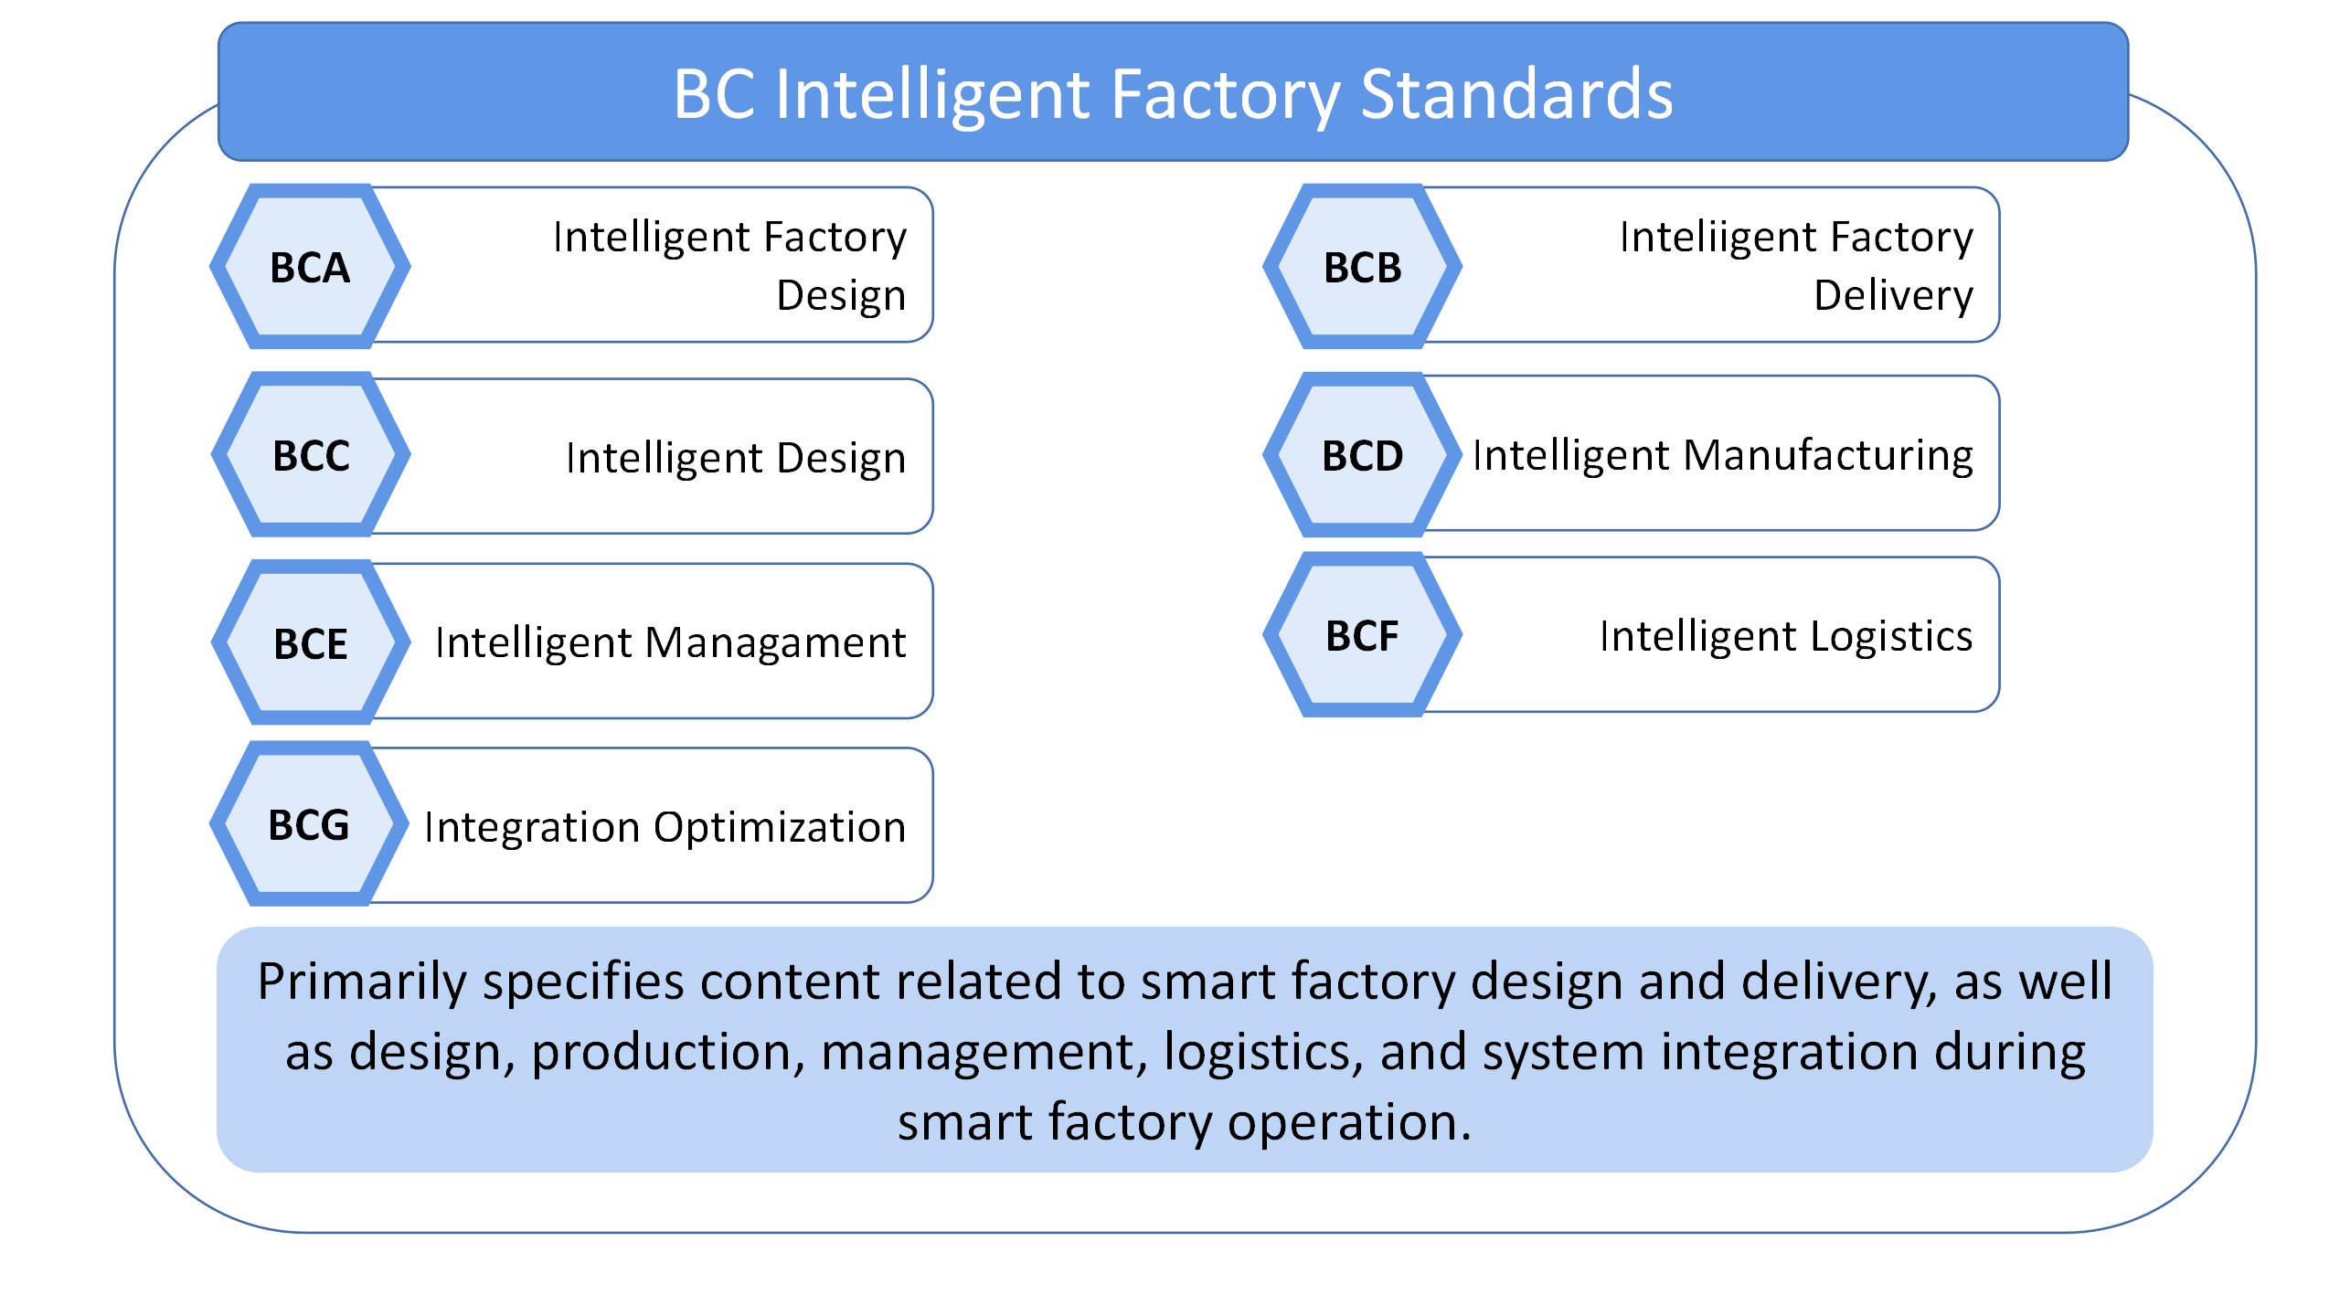

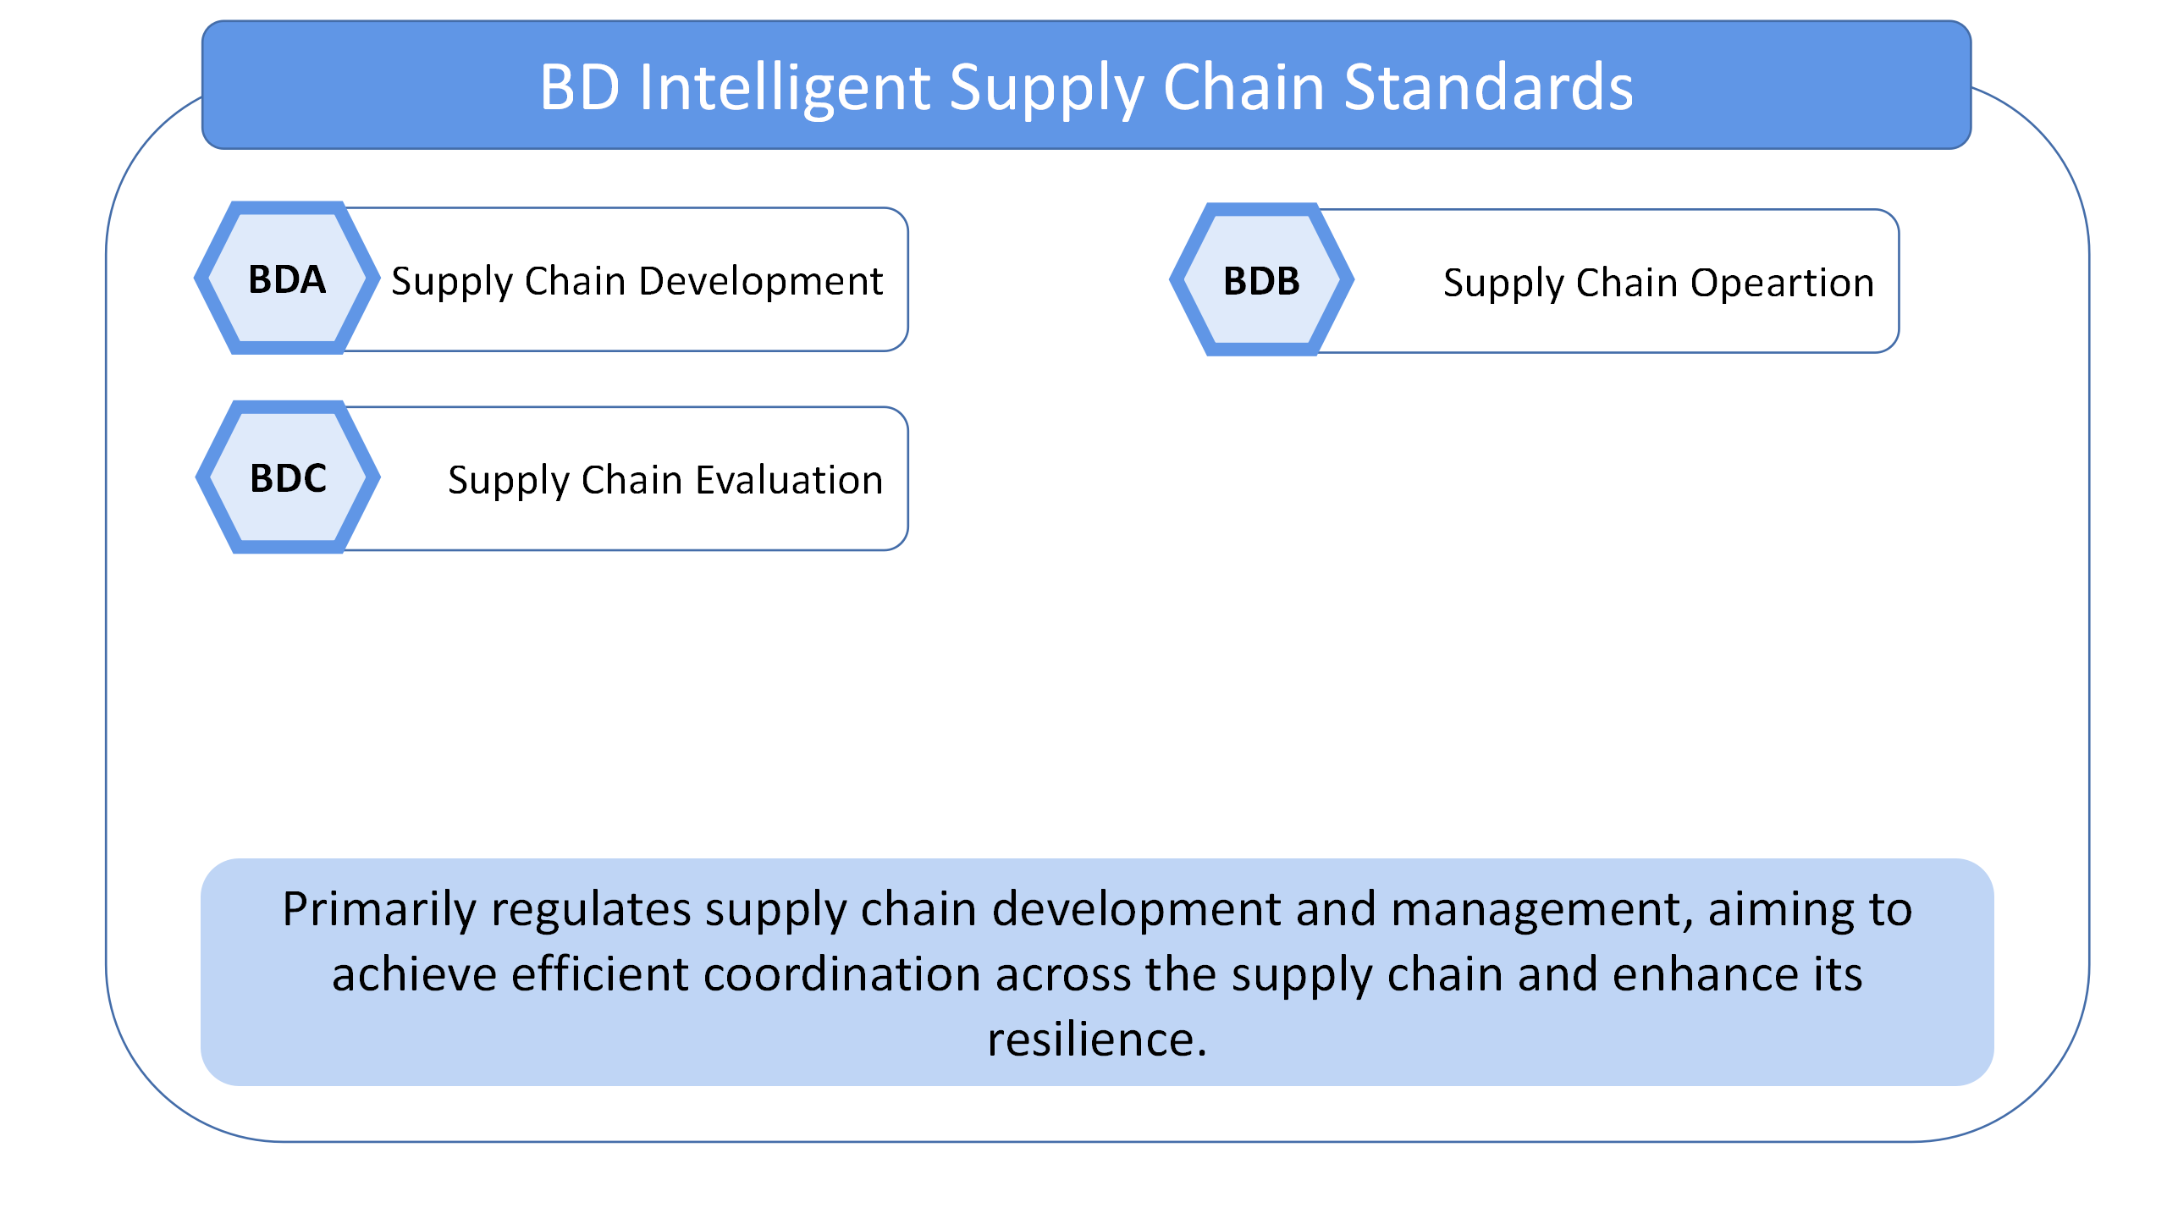

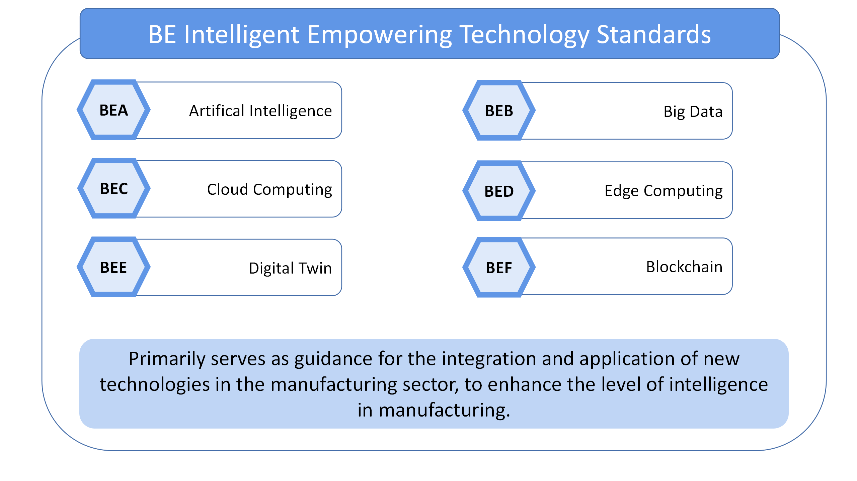

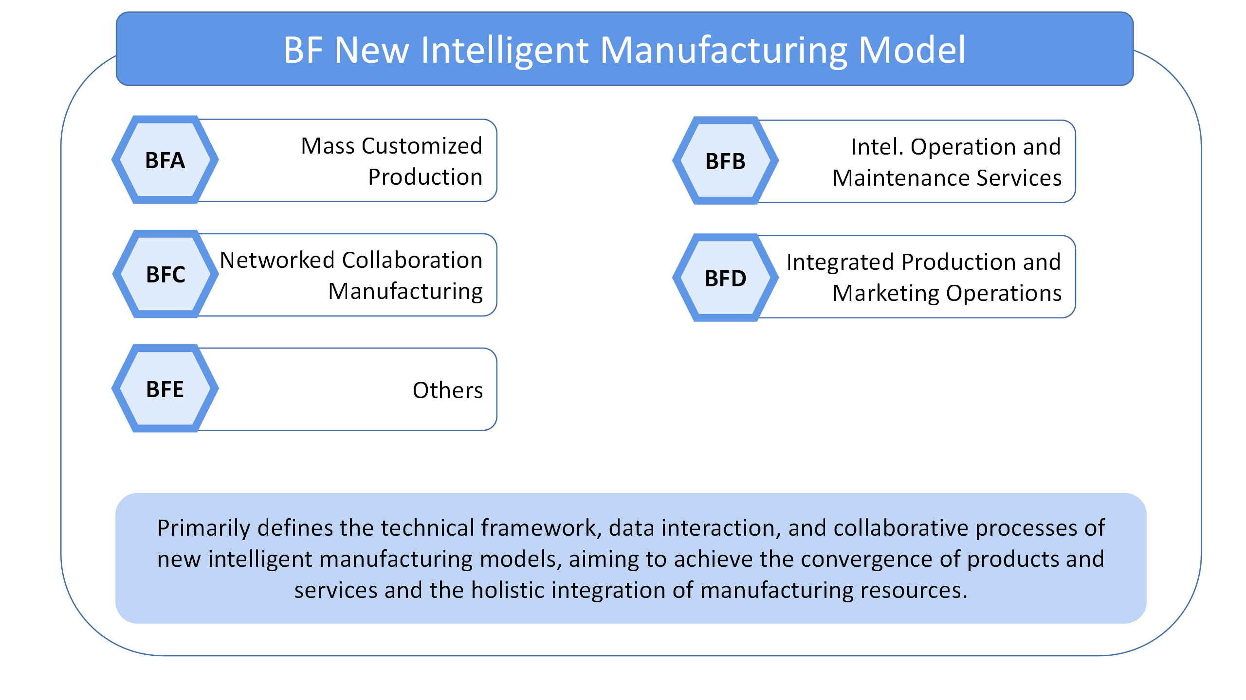

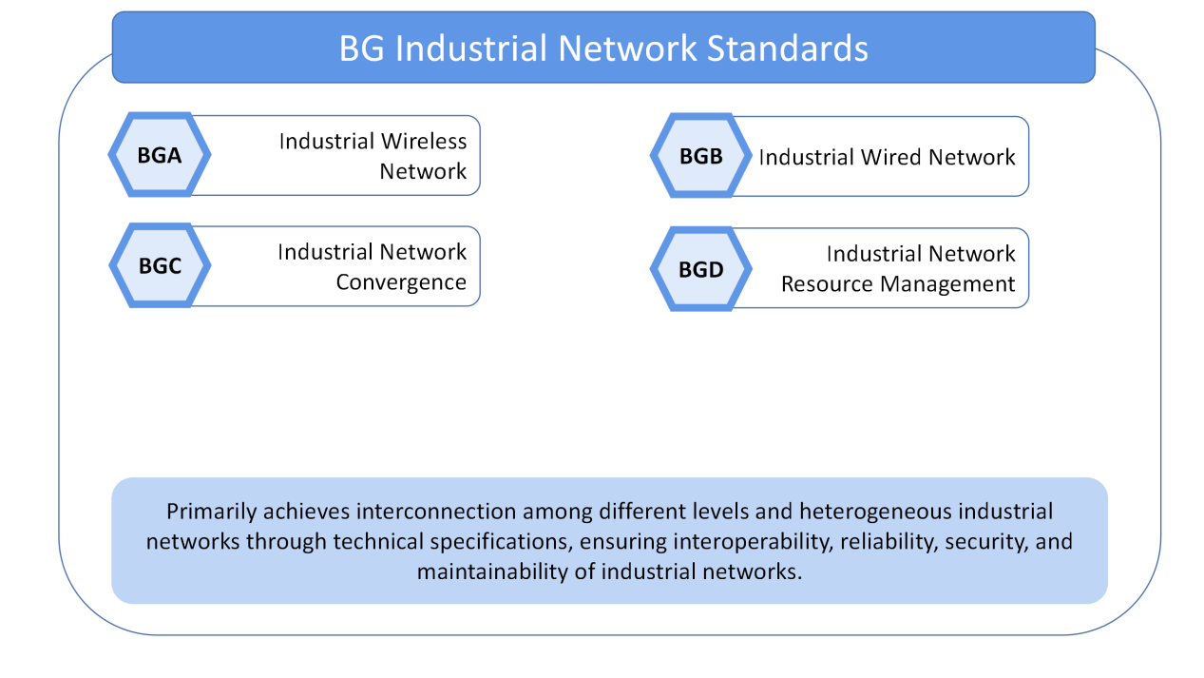

**Industry Applications**

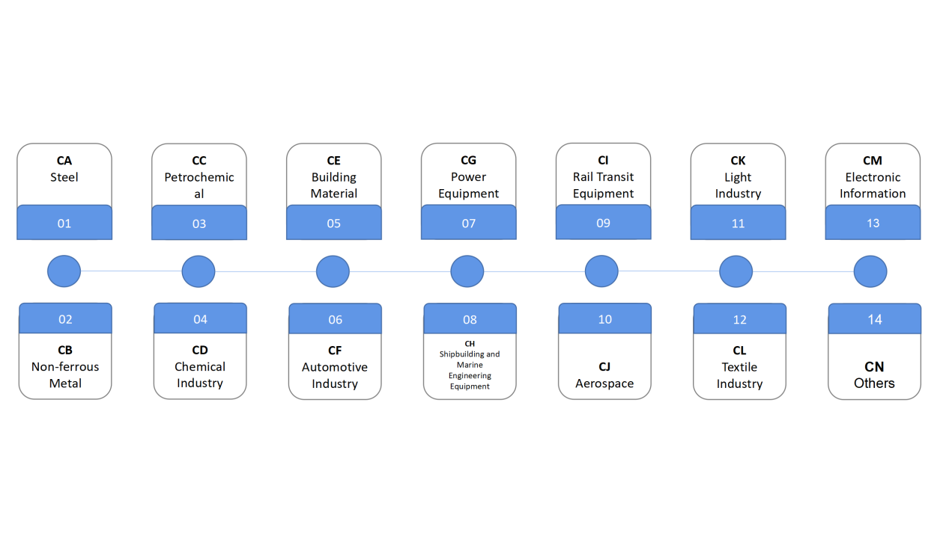

1. **Methodology for Developing Standards Systems in Sub-Sectors**  
   Leverage the guiding role of the national standards system, and tailor approaches to the characteristics of each industry. Focus on pressing issues that have emerged in the sector over the past three years. Analyze the applicability of national foundational and key technology standards, and, based on the selection of relevant national standards in these areas, ensure alignment and compatibility between industry standards and national standards. Identify key directions for standard development in each sub-sector and accelerate the advancement of intelligent manufacturing standards systems at the industry level.
2. **Standard Development Priorities for Sub-Sectors**  
   Focus on standards related to digital workshops, intelligent factories, process workflows, business management, and the application of new technologies.
3. **Implementation Mechanism**
4. **Strengthen Overall Coordination**  
   The National Intelligent Manufacturing Standardization Coordination and Promotion Group, Expert Advisory Group, and General Working Group will enhance guidance and collaborative efforts to promote the standardization of outstanding practical achievements.
5. **Accelerate Standards Development**  
   Explore new approaches to tackling standardization challenges, encourage enterprises to propose standardization projects with independent intellectual property rights, and strengthen the capabilities for preliminary research and testing of key technologies and industry application standards.
6. **Enhance Standards Application**  
   Foster a group of industry benchmarks for standard implementation, establish sets of standards tailored to typical application scenarios, and encourage upstream and downstream enterprises—especially small and medium-sized enterprises (SMEs)—to carry out benchmarking activities, thereby improving their capacity to apply standards effectively.
7. **Implement Dynamic Updates**  
   Establish a feedback mechanism linking standards development and application, revise the National Guidelines for the Development of the Intelligent Manufacturing Standards System in a timely manner, and encourage industries and enterprises to actively participate in building their own intelligent manufacturing standards systems.
8. **Strengthen International Cooperation**  
   Actively participate in international standardization activities, deepen bilateral and multilateral cooperation mechanisms such as China-Germany, China-France, BRICS, and the Belt and Road Initiative, and proactively contribute Chinese solutions to the global standardization landscape.

**Introduction of SESEC Project**

The Seconded European Standardization Expert in China (SESEC) is a visibility project co-financed by the European Commission (EC), the European Free Trade Association (EFTA) secretariat and the three European Standardization organizations (CEN, CENELEC and ETSI). Since 2006, there has been four SESEC projects in China, SESEC I (2006-2009). SESEC II (2009- 2012), SESEC III (2014-

2017), SESEC IV (2018- 2022) and SESEC V

(2022-2025). Dr. Betty XU is nominated as the SESEC expert and will spend the next

36 months on promoting EU-China standardization information exchange and EU-China standardization cooperation.

The SESEC project supports the strategic objectives of the European Union, EFTA and the European Standardization organizations (ESOs). The purpose of SESEC project is to:

* + - **Promote European and international standards in China;**
* **Improve contacts with different levels of the Chinese administration, industry and standardization bodies;**
* **Improve the visibility and understanding of the European Standardization System (ESS) in China;**
* **Gather regulatory and standardization intelligence.**

The following areas have been identified as sectoral project priorities by the SESEC project partners: Internet of Things (IoT) & Machine-to-Machine(M2M) communication, communication networks & services, cybersecurity & digital identity, Smart Cities (including transport, power grids & metering), electrical & electronic products, general product safety, medical devices, cosmetics, energy management & environmental protection (including eco- design & labeling, as well as environmental performance of buildings).